OT11 Post-Exilic History: Ezra, 1 & 2 Chronicles, Nehemiah, Esther
Dr. Marvin J. Effa
Ezra
Author: The first person memoirs (see 7:27–9:15), genealogies, and documents is probably the work of Ezra. Although Ezra is not mentioned in the book as its author, he most likely did write the book using various documents (e.g., 4:7–16), genealogies (e.g., 2:1–70), and personal memoirs (e.g., 7:27–9:15) as his sources.
Date of writing: 450–444 B.C.
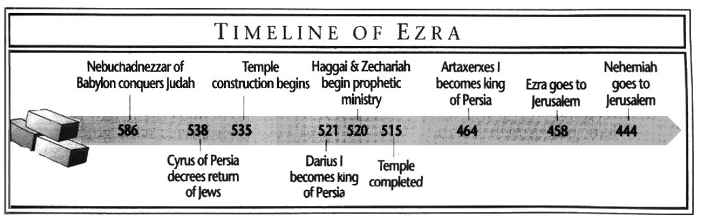

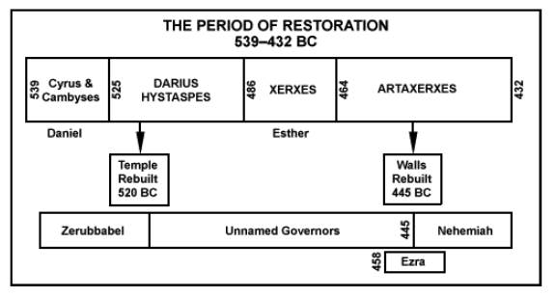 | 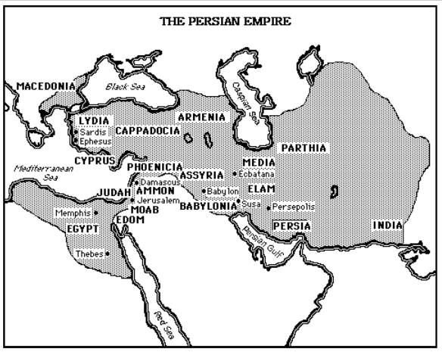

Purpose: to show that the Lord fulfilled His promise announced by the prophets to return the people from Babylon, to rebuild the Temple, to restore the Temple worship according to the law and to preserve the reassembled community from relapses into idolatrous worship.
Idea: God is at work in resolving difficult problems to the end that His people have closer fellowship with Himself.

Development:
- Success and setbacks: the rebuilding the temple with Zerubbabel, Ezra 1:1-6:22.
- Success and setbacks: the restoration of the people under Ezra, Ezra 7:1-10:44.

Key Passage Exegesis
- Restoration is typically less than pre-judgment experience, Ezra 3:12-13.
- The difficult problem of pagan wives, Ezra 9-10.

1 & 2 Chronicles
Author: Ezra has traditionally been assumed to be the author.
Date of writing: 450–425 BC
Purpose: Ezra writes 1 and 2 Chronicles (originally one book), to provide a divine perspective of the history of Israel that focuses on David and the temple. This history will assist the rebuilders in developing a proper worship of the Lord in the rebuilt temple.
Idea: Events are not random, but follow the Lord’s blessing and punishment of His people.
Development:
- Genealogies, 1 Chronicles 1-9.
- The Reign of David, 1 Chronicles 10-29.
- The Reign of Solomon, 2 Chronicles 1-9.
- The Reign of the Davidic Dynasty, 2 Chronicles 10-36:16.
- The Babylonian Conquest and Exile, 2 Chronicles 36:17-21.
- The decree of Cyrus, 2 Chronicles 36:22-23.

Key Passage Exegesis
- The most extensive collection of genealogies, 1 Chronicles 1-9.
- Blessing will follow repentance, 2 Chronicles 7:14.
- Patterns of obedience/blessing and disobedience/judgement, 2 Chronicles 15:1-7.
- The Lord seeks loyal hearts, 2 Chronicles 16:9, 12.
- Manasseh’s conversion, 2 Chronicles 33:12-13.
- Josiah’s arrogant refusal to listen to Necho, 2 Chronicles 35:22, 25.
- Zedekiah’s rebellion, 2 Chronicles 36:12-13.

Nehemiah
Author: According to Nehemiah 1:1, Nehemiah is the author, but he may have used sources as Nehemiah 7:5-73 is almost identical to Ezra 2:1-70.
Date of writing: 445-435 BC
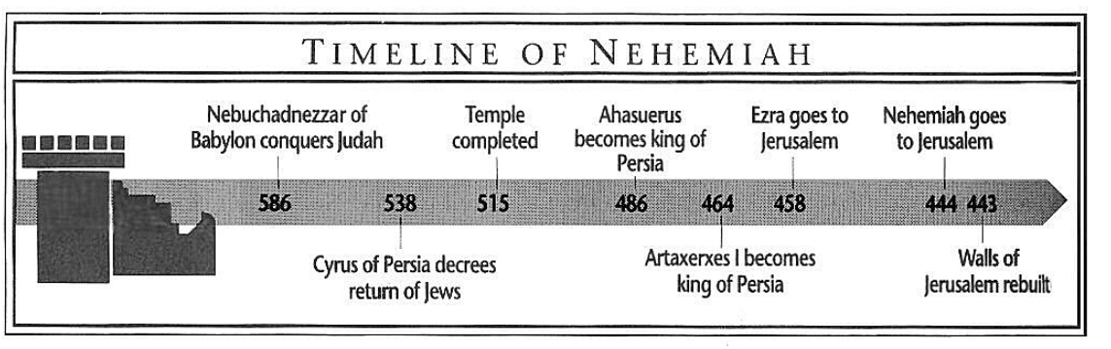
Purpose: to track Nehemiah’s efforts to establish a Jewish national identity that followed the Mosaic Law, but still remained under Gentile domination.
Idea: The Jewish people should maintain their identity during the Times of the Gentiles and adhere to as much of the Mosaic Law as possible.

Development:
- Rebuilding the Walls (Under Nehemiah), Nehemiah 1:1–7:73.
  - The Return to Jerusalem, Nehemiah 1:1–2:20.
  - The Rebuilding of the Walls, Nehemiah 3:1–7:4.
  - The Register of People, Nehemiah 7:4–73.
- Renewing the Covenant (Under Ezra), Nehemiah 8:1–10:39.
- Reforming the Nation, Nehemiah 11:1–13:31.
  - Repopulating the Cities, Nehemiah 11:1–12:26.
  - Rededicating the Wall, Nehemiah 12:27–47.
  - Enforcing the Mosaic Law in the restored nation, Nehemiah 13:1–31.

Key Passage Exegesis
- Obtaining permission from pagans to accomplish God’s will, Nehemiah 1-2.
- Legal, but not good, Nehemiah 5:9.
- Knowledge of the Word protects against false prophets, Nehemiah 6:10-14.
- Mixed multitudes are excluded, Nehemiah 13:3, 27.

Esther
Author: Possibly Mordecai; according to Esther 9:20, he wrote on behalf of King Ahasuerus.
Date of writing: 464 BC, after the death of Ahasuerus (Esther 10:1-3 speaks of his reign in the past tense).
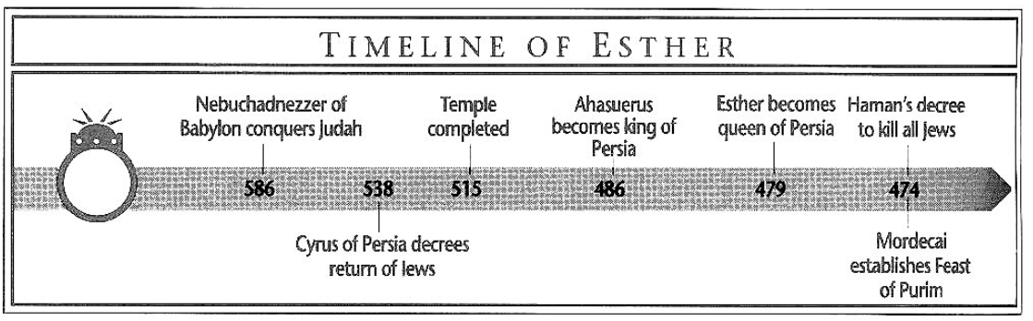
Purpose: to show God’s sovereign care for His people during the Times of the Gentiles.
Idea: God often puts key people in place to protect and care for His people.
Development:
- Esther Placed in a Position of Prominence, Esther 1:1-2:20.
- The Jews Marked for Extermination, Esther 2:21-4:3.
- Calamity Averted by Esther, Esther 4:4-9:19.
- Feast of Purim Established, Esther 9:20-32.
- Greatness of Mordecai Described, Esther 10.

Key Passage Exegesis
- God brings key people into positions that provide the opportunity to great good for the people of God, Esther 4:14.

MacDonald, W. (1995). Believer’s Bible Commentary: Old and New Testaments. (A. Farstad, Ed.) (p. 471). Nashville: Thomas Nelson.
Ryrie, C. C. (1995). Ryrie study Bible: New American Standard Bible, 1995 update (Expanded ed., p. 720). Chicago: Moody Press.
G. Michael Cocoris, 2016 Euclid #20, Santa Monica, CA 90405, The Bible: Book by Book, 2000, internet paper.
Ryrie, C. C. (1995). Ryrie study Bible: New American Standard Bible, 1995 update (Expanded ed., p. 625). Chicago: Moody Press.

